WASHINGTON STATE UNIVERSITY

Infrastructure-Grimes Way Realignment

2013 – 2015 Request: $36,000,000 Project Type: Infrastructure
Project Phase: Design/Construct
Institution Priority: #12 Gross Square Ft: N/A

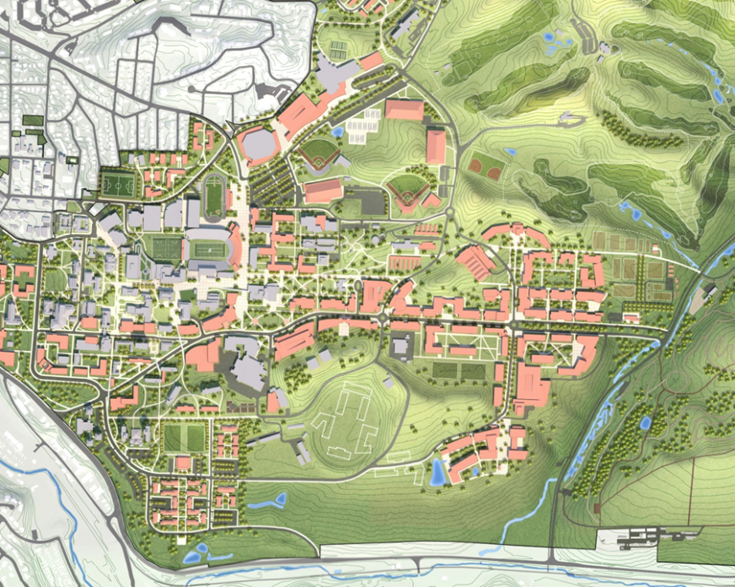
The Grimes Way bypass project is the first step to implement the Pullman Campus Master Plan. The realignment project connects Stadium Way -- the current main artery of both traffic and infrastructure -- to what will become the next main artery for the future growth of the campus. It has been the University’s planning policy to install major utilities within the road beds rather than extend them cross- country, making them available to the buildings and facilities along either side of the road, consistent with most all municipal plans. The utilities within Grimes Way have exceeded their useful life and are also inadequate to support future projects.

WSU’s recent master plan includes an infrastructure/utilities master plan to support the development and implementation of the campus build out and expansion of the academic and research requirements east of Stadium Way. The first phase of this plan is to realign Grimes Way and expand the campus underground utilities (stormwater, wastewater, potable water, chilled water, steam/condensate, IT network, & 13.2KV distribution) to support current and future academic and research facilities. The realignment of Grimes Way starts just southeast of the Stadium Way and Grimes Way intersection, continues east to Dairy Road and where a bypass will be installed to intersect with North Fairway Road.

The plan for this project includes a pedestrian mall, which will provide the backdrop for infrastructure changes on the east side of campus. The creation of the new walking spaces enhances safety, mitigates the need for upgrade and maintenance of two signal lights, provides opportunities for larger scale interaction of the campus community, tying athletic facilities and services and the research communities together while promoting good environmental practice. Air quality improves from reduced traffic and modern construction methods will bring opportunities to employ new methods of surface water control through pervious paving techniques and other Low Impact Development (LID) technologies.

The fulfillment of this phase of the master plan addresses a number of the University’s long term goals: pedestrian safety, redirecting traffic through campus, reduced energy consumption and emissions, replacing/upgrading existing utilities and infrastructure build out for future academic and research development east of campus.

