WASHINGTON STATE UNIVERSITY

Troy Hall Renovation

2013 – 15 Request: $4,350,000 Project Type: Program (Renov/Growth)
Project Phase: Design
Institutional Priority: #6 Gross Square Ft: 38,641

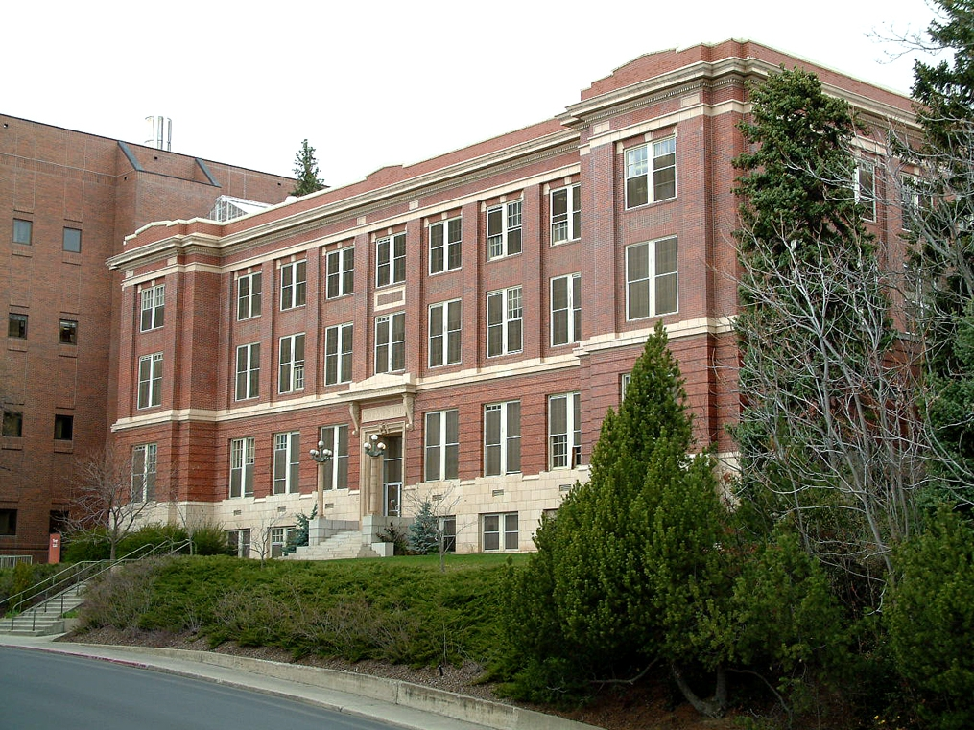
A full renovation is required for Troy Hall, a 1920s brick building in the core of Washington State University’s Pullman campus. The building is structurally sound, but has received little in capital expenditures over the past 50 years. Parts of the building have deteriorated or are in substandard condition. Renovation will provide much-needed modern space for academic instruction, multidisciplinary interaction and cutting-edge research.

Remodeling and modernizing Troy Hall will directly support the growth and development of programs in chemical and environmental sciences, which in turn support the university’s commitment to STEM education and training. Such education and training leads to well-trained employees and entrepreneurs who contribute to the state’s economy. The availability of high-quality modern facilities also directly impacts WSU’s ability to recruit and retain the best faculty and motivated students.

The university is dedicated to providing students with the tools they need to become engaged and productive members of society. Both quantitative reasoning and basic science courses are included in the graduation requirements for all undergraduate degrees. Limited laboratory space means limited resources for scientific discovery and limited course instruction. The number of students present in a lab is strictly controlled to ensure safety and quality of instruction. Today, graduate and undergraduate programs in chemistry are experiencing rapid growth. And chemistry facilities support more than just chemistry majors. Students majoring in disciplines such as agriculture, biotechnology, engineering, food science, physics, and pre-health science programs for disciplines including medicine, dental, nursing, pharmacy, veterinary medicine, physical therapy and the like are required to take a range of chemistry courses.

The Troy Hall renovation would also provide space for environmental science programs and a unique cross-college academic unit comprised of educators and researchers who are passionate about our planet, sustainability and the natural environment. High-demand environmental degree programs will be enhanced by locating the faculty, staff and graduate students in close proximity to one another and by providing much needed space for offices, modern dry and wet laboratories and instruction.

Renovation of Troy Hall has been in university master plans and on the 10-year capital plan for many biennia. Predesign work for renovation of Troy Hall was completed in 2003-05 and was recently updated to reflect changes in the university’s strategic plan and master campus plan regarding space needs of high-demand science programs. Additionally, Troy Hall features prominently in the campus facility plan to preserve existing facilities and to retain the historic atmosphere of the campus core.

Troy Hall is an important part of the existing Pullman campus space inventory and occupies a strategic location for the sciences. Preserving and modernizing this building will help the university meet the demand in these fields and more efficiently and effectively educate its students.

