WASHINGTON STATE UNIVERSITY
WSU Pullman: Plant Growth (Greenhouse) Facilities Ph1

2013 – 15 Request: $225,000 Project Type: Program (Research/Growth)
Project Phase: Predesign
Institutional Priority: #7 Gross Square Ft: 34,000

Plant science research at WSU is recognized internationally and is one of WSU’s major areas of excellence. However, this reputation is threatened because a major portion of WSU’s plant science support infrastructure, greenhouse and controlled environments are over 50 years old. The control systems are dated, the plumbing and electrical utilities are old, the physical and biological security is poor and the facilities are energy inefficient and expensive to operate. There is a critical need for new facilities capable of supporting innovative teaching and research with greater precision, efficiency and security.
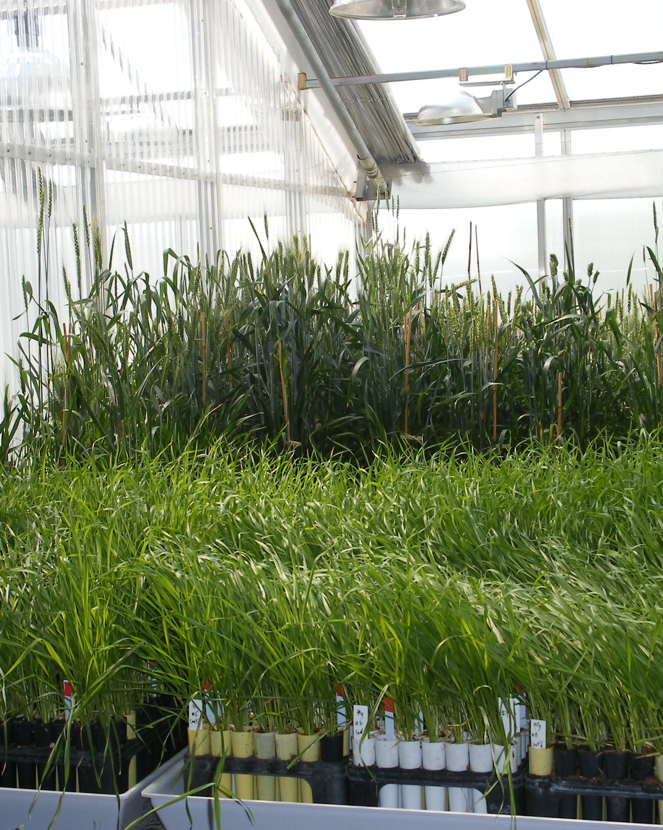
The Wheat Plant Growth Facility,
built in 1997, has been very valuable to WSU’s plant science research.

The research conducted in these facilities is critical if WSU is to support the agricultural industries of the state, to maintain pre-eminence in international agricultural research and to educate more students. The research also provides information that helps develop a fact-driven basis for public policy decisions which is so important to Washington citizens’ quality of life. A multi-phase rebuilding plan is essential to bring facilities to a point where it is possible to conduct research that describes fundamental aspects of plant sciences, from the growth of individual plants to the plant-based natural and agricultural ecosystems. This building project proposal is the first phase of the plan.

In the late 1990’s, WSU began to search for a wheat geneticist but several candidates rejected the position because of inferior and limited plant growth facilities. The Wheat Plant Growth Facility was built to meet this demand but since its completion in 1997, there has been no major upgrade in the WSU plant growth facilities. Meanwhile, institutions such as North Dakota State University (http://goo.gl/TlP0u), Missouri’s Donald Danforth Center (http://goo.gl/I1SYR) and Australia National University (www.plantaccelerator.org.au/) have developed the facilities needed to carry out plant science research at a higher level than WSU. Having modern facilities has become critical for winning federally competitive grant awards and recruiting and retaining high quality faculty and students.

In this first phase, the university is requesting a plant growth facility with space partitioned into a number of independently controllable greenhouse areas that will allow excellent plant growth under various environmental conditions (light intensity and quality, temperature, humidity, etc.). The facility would also contain approximately 50 growth chambers, including both walk-in and reach-in chambers, which are needed to increase the precision and flexibility of plant growth conditions and for special research purposes.

The WSU Pullman Campus Master Plan includes new plant growth facilities and also articulates a desire to construct research buildings along Grimes Way, on sites where older greenhouses are currently located. To avoid interruption of critical research, replacement greenhouses would first need to be constructed.

